Nuremberg Party Rallies
NSDAP calendar of holidays & celebrations:

- The Day of the Seizure of Power (January 30)
- Foundation Day of the NSDAP (Feb. 24)
- Veterans’ Day (March)
- Hitler’s Birthday (April 20)
- National Labor Day (May 1)
- Mothering Sunday (May)
- Summer Solstice Day (June)
- Nazi Party Rallies (September)
- Harvest Thanksgiving Day (October)
- Remembrance Day (November 9)
- Christmas Eve (December 24)

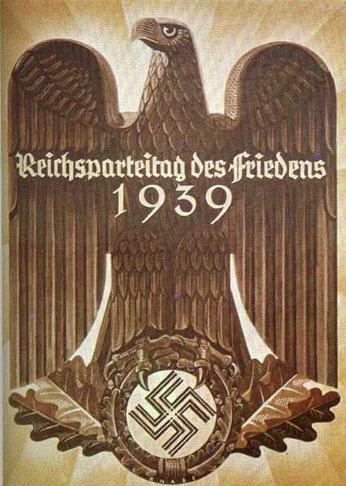
Selected responses in the foreign press to the NSDAP Party Rallies:
- After the fever of Fascist hysterics has reached its maximum, Hitler’s troops have returned to their regions. The Congress was dominated by more or less implausible and deceptive speeches delivered by the bosses, the party basis and the youth did not have a say… These bandits who cannot guarantee basic supplies to their people, now offer their troops who are livid with rage anti-Semitic pogroms! [L’Humanité (September 4, 1933)]
- Three hundred and fifty-seven trains are bringing the forces of National Socialism from every part of Germany to this city of medieval houses, which was great when Berlin was but a village, for the first congress of the National Socialist party since Herr Hitler became absolute master of Germany. Everywhere in streets and hotels and cafes are leaders and organisers who wear brown uniforms cut exactly like those of British soldiers in wartime. [The Daily Mail (September 6, 1933)]
- The young Germany is showing its strength. And young Germany is very strong. [New York Times (September 4, 1933)]
- Sacrilegious though it may seem, Germany of today can be explained to the foreigner only if he is made to realize that the great German nation has a Messiah-complex and that Hitler is the incarnation of their hopes for better days. [Chicago Daily News (September 10, 1934)]
- I do not believe that within living memory there has been a spectacle that could compare to this in size and beauty—National Socialism, which is often found wanting in spirit and intellect, has found its genius. With the aesthetics of this stage production it now supplements it cultural heritage. What used to be action and activity has now become a ritual. Such is the history of each religion, thus also of the National Socialist religion. [L’Echo de Paris (September 9, 1934)]
- The organizers of the concentration camps, barbarians who have lost their human face will be talking about protecting civilization. Thugs who burn books and ban verses by Goethe and Schiller from German school readers, will be talking about culture. [Pravda (September 6, 1936)]
- Endless drill until they almost faint, incessant bawling which is supposed to be ‘enthusiasm’, cheap trinkets, flashy decorations, rampant, almost hysterical anti-Soviet screaming—all this nonsense follows a specific goal. It makes sure that people don’t have time for reflection. [Izvestija (September 16, 1936)]
- The tenth meeting of the Swastika movement was a full, undisputed success of superb organization, which has had to deal with more difficult and bigger tasks every year. The success of the Führer was also incredible, with the German people trusting him more and more strongly and expressing its willingness to follow him, even in difficult times. [Il Messagero (September 12, 1938)]

Eyewitnesses recall:
- For me the Party Rallies were just about as important as Christmas. My friends and I had a kind of competition: Who could see the Führer the most times. In 1937 I saw him twelve times, and in 1938 thirteen times…. And can also remember seeing that he sometimes smiled a little when he came out and even greeted us. [Käthe Fettahoglu (born 1923) during interview in 2000]
- It was always particularly difficult for us during the Party Rallies. On the one had these rallies were usually during our High Holidays, that is [Jewish] New Year and Yom Kippur…. When we pushed our way through the crowd, with our prayer books, that was some adventure, because we knew exactly that is we were caught with our Jewish prayer book tucked under our arms, all hell would be set loose! [Arno Hamburger (born 1923) left Nuremberg in 1939 and went to Palestine]
- There was a community feeling, they liked parades, and to be given an award on Sundays because you could march well—that was a real experience. Yes, only especially selected people were allowed in. If we had been pulled aside afterwards, because we had marched worse than the others, then we would have cried our hearts out, I’m sure of it. [Reinhold Schwiddesen (born 1919) during interview in 2000]
- The stones that we worked were sent afterwards in the ‘Galle’ (stonemason barracks) to the stonemasons. When the trucks came to pick them up, we helped load them up. They were transported to various cities, including Nuremberg…. I remember one driver well who came from Nuremberg. His name was Max… There was a lot of sadism. Many were injured by falling stones or killed. No safety measures were observed, no medical aid given. Every day was the same. The men quarried the stones here, half-clothed, with wooden shoes which made your feet bleed, without gloves. [Sergej Rybalka (born 1925) deported from Ukraine in 1942 by the Wehrmacht for forced labor in Germany]

Leni Riefenstahl recalls:
- Two million people can gather in Nuremberg, the City of the Party Rallies. 60 million Germans must witness this gigantic parade… Above all of this it was the close link between the “Führer” and his people which was the major experience over and over again. One of the main tasks I set for myself is expressing this feeling.
- I designed the film in such a way that it will rouse its audiences, uplifting them more and more from act to act, from impression to impression.

